**SENSORS & ACTUATORS**

Sensors and actuators are the most integral part of any system. The information collected by the sensors are used to make the actuators to do a particular output operation. All this communication and control is done using a controller. Controller decides which sensor data is paired with which actuator and what operation must be performed.

**ACTUATORS**

Actuators act as output devices and are attached to the output port of the controller. Their purpose is to convert the applied electrical energy into a particular physical operation.

**DC MOTOR**

The base cart unit is driven by the DC motor. The DC motor works in correspondence with the sensor and helps to balance the pendulum. The signal given to the DC motor is changed according to the feedback received by the sensors monitoring the system. A DC motor converts electrical energy in to mechanical energy. When a current carrying conductor is placed in a magnetic field, a magnetic force is created which produces a torque. The direction of the mechanical force can be determined using Fleming’s left hand rule. Looking into the internal working of the motor, it consist of coils acting as the conductor which forms the armature. It is placed in a constant magnetic field provided by the stator. The current is made to flow through the coil through commutator rings. This causes the rotation of the coil. More the number of coils smoother the rotation of the motor will be. (StudyElectrical.Com 2020)

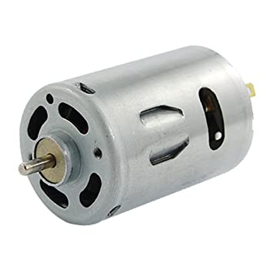

**Fig 2.1:** 6000 RPM Electric motor (Amazon 2020)

**Specifications**

|  |  |  |
| --- | --- | --- |
| **Parameters** | **Value** | **Units** |
| Motor nominal voltage | 6 | V |
| Motor maximum continuous current | 1 | A |
| Motor maximum speed | 6000 | RPM |
| Planetary gear box ratio | 3.71 |  |

**Table 2.1:** DC motor specifications

**SENSORS**

Sensors work as input devices and they are connected to the input ports of the controllers. Their purpose is to detect and measure the physical parameters and generate an output usually in the form of an electrical signal.

**ROTARY ENCODERS**

It is also called as a shaft encoder, it converts the motion of the shaft into output signals. It is used to determine the angular position of a rotating shaft. The shaft is attached to the disc inside the encoder. The rotation created in this disc is monitored to calculate the change in position. All these workings happen within the encode itself. From the change in position we are able to obtain the distance travelled, which could be linear or angular motion.

The classification of Rotary encoders are represented in Fig 2.2

Rotary Encoders

Sensing Technology

Output Signal

Optical

Laser

Magnetic

Incremental

Absolute

**Fig 2.2:** Classification of Rotary Encoder

They are classified based on the output signal and the sensing technology. Based on the output signal, it is divided into Absolute and Incremental. In our system we will be using incremental encoders in our system as they provide immediate changes in position. The sensing technology is just how the rotation of the disc inside the encoder is measured, it maybe magnetic, optical or laser. (HowToMechatronics 2020)

Our system is equipped with two encoders,

1. **First one to measure the position of the cart.**

These are called as position encoders or rotary encoders. We are using a measuring wheel encoder to measure the linear distance of the cart. As the cart moves the wheel also moves respectively which rotates the shaft helping to measure the distance travelled.

1. **Second one to measure the position of the pendulum shaft.**

This uses a similar encoder where the shaft is fixed to the pendulum to detect its position

**Specifications**

|  |  |  |
| --- | --- | --- |
| **Parameter** | **Value** | **Unit** |
| Cart encoder resolution | 4096 | counts/rev |
| Pendulum encoder resolution | 4096 | Counts/rev |

**Table 2.2:** Encoder specifications

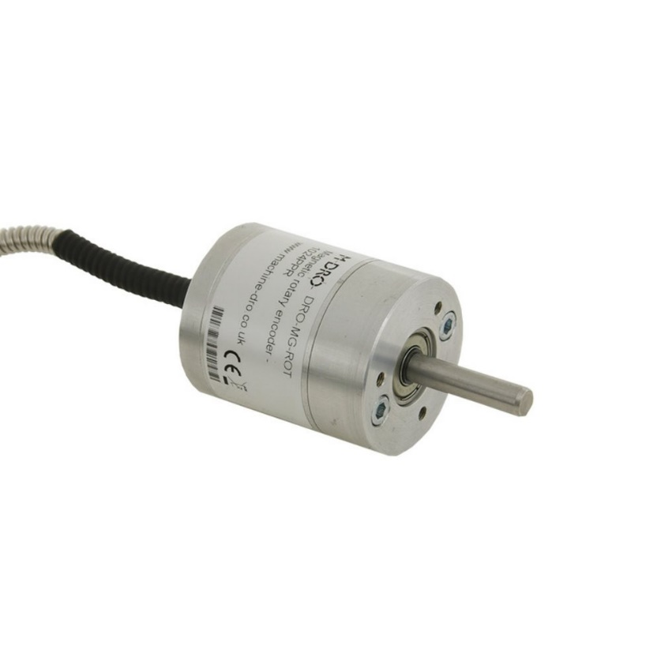

**Fig 2.3:** Rotary encoder (Machine-dro 2020)

**Working of the System**

The two rotary encoders constantly monitor the position of the cart and the pendulum arm and sends position data in the form of signals to the controller. Depending on the position, the controller sends corresponding signals to the DC motor. The DC motor is responsible for the movement of the cart. As the position sensed by the encoders change, the controller changes its signal respectively. So, the controller constantly sends signals to the DC motor to move the cart in order to counter balance the weight of the pendulum and keep the pendulum balanced in the upright position.

Let us now look at some of the other commonly used sensor, its principle, working and applications.

**ANGLE SENSOR**

The purpose of an angle sensor is to measure the displacement of an object with respect to a reference position. This position sensing is necessary so that the physical characteristic that is the position can be converted into a format that can be understood by the system. In most cases the angular mechanical position is converted into electrical signals. Every application requires a particular type of angle sensor with particular specifications. Few applications of angle sensors are steering wheels, forklifts, robotics and machinery. The working of an angle sensor can be understood better while looking at one of its applications. A major application of an angle sensor is the steering angle sensor (SAS). The steering sensors can be Optical, Non-contact, Magneto resistive or Hall type. Its function is to transmit the data of the steering angle to the Steering control module. Usually two sensors are packed into a single unit for more accurate reading. The two signals obtained by these sensors are compared against each other for accuracy. Like most sensors for SAS we can have analog or digital. For an Analog SAS a signal is produced that changes between 0 and 5 volts as the wheel is turned 360 degree. In case of a Digital SAS, after the angle is measured it is converted into a compatible format and shared with a module through a serial data bus. (Know Your Parts 2020)

**GYROSCOPE**

Gyroscope is a device used for measuring and maintain the orientation and angular velocity of the system. It helps in monitoring the rotational motion. A classic gyroscope consists of a wheel mounted on an axis. The wheel can move freely and assume any orientation. The spinning wheel produces a torque which helps in maintain the orientation. It works on the principle that angular momentum changes in the direction of Torque. Since the gyroscope is able to maintain its orientation in space, it has huge applications in Aircrafts. When an aircraft tilts, the electronics sensors connected with the gyroscope are able to measure the displacement in the aircraft’s orientation which is then sent to the pilot. Other applications include space rovers, Space rockets, submarines, etc. Modern electronic gyroscopes have found their way into smartphones to access various applications. There are commonly used along with an accelerometer. Modern electronic sensors have been developed with both the gyroscope and the accelerometer packed into a single unit. (Gyroscopes: What They Are and How They Work? 2020)

**ACCELEROMETER**

The difference between a gyroscope and an accelerometer is that the gyroscope measures the orientation while the accelerometer measures the linear acceleration. Accelerometer works by picking up any vibrations or change in motions. The vibrations create a forces which causes a stress on a material which in turn produces an electrical charge which is propositional to the force applied. Force is proportional to mass and acceleration, where mass remains constant. Hence, the charge that is generated is propositional to the acceleration. Accelerometers are divided into three types namely, Capacitive MEMS Accelerometer, Piezoresistive Accelerometer and Piezoelectric Accelerometer depending on how the change is generated. (Steve Hanly 2020)

**Capacitive MEMS Accelerometer**: Micro Electro Mechanical Systems (MEMS) is a technology to manufacture miniature electric and mechanical components. Capacitive Accelerometer works on the basis of changes in capacitance. When there is a vibration it causes a change in distance between the two metal plates of a capacitor which results in change in capacitance. So the electromechanical system is able to sense a movement and convert it into a changing capacitance value. Then a circuitry can be designed to read this change in capacitance and change it into useful data.

**Piezoresistive Accelerometer:** This works by inducing changes in resistance of strain gauges in the system. It is mostly used for crash testing because it has very wide bandwidth which provides the ability to measure short duration vibrations.

**Piezoelectric Accelerometer:** They use piezoelectric materials like lead zirconate titanate (PZT) as sensing elements. The occurrence of any vibrations induces a stress on the material. These piezoelectric material produces an electric charge that is propositional to the stress applied.

**ULTRASONIC SENSOR**

An Ultrasonic sensor uses ultrasonic sound waves to measure the distance to an object. It works by emitting high frequency sound waves, receives the sound waves that is reflected back by any object and calculates the distance based on the time taken for the sound to travel back to the sensor. These sound waves are ultrasonic with frequency above 20KHz which is too high for the human ear. They work up to a range of 3.5 meters. Just a single transducer is used for the process of transmitting and receiving. A transducer is able to convert a physical quantity like sound waves into electrical signal or vice versa. The distance can be calculated by using the formula:

Distance = ½ T x C

(T= Time and C = speed of sound)

They provide a cost effective and reliable method of object sensing and to measure distance. Let’s focus on what makes the ultrasonic sensor so reliable. They are not affected by external environmental effects like smoke, dust, noise and light. They are indented of object surface, texture and colour. So, they provide great application in fluid level sensing. But in the presence of any sound absorbing material, distortion of sound waves my take place. Looking into its applications, it can provide a non-contact method of distance measuring using is useful in manufacturing and production lines. (Fierce Electronics 2020)

**LIGHT SENSORS**

Light sensors are converts light energy (photons) into electrical signal (electrons). Depending on the intensity of light the light sensor generates a propositional output signal. It measures the radiant energy within a very narrow frequency spectrum from infra-red to ultraviolet. They are also commonly referred to as photoelectric devices because of the ability to convert light energy into electricity. The Photo electric devices are classified as follows: (Basic Electronics Tutorials 2018)

**Photo-emissive Cells:** It works on the principle of photoelectric effect, where a light sensitive surface when struck by photons emits electrons. When the cathode that is the light sensitive material is struck by photons, the electrons gain enough energy to escape the surface. Then these electrons are attracted towards the anode. This movement of electrons from the cathode to the anode makes up the electric current. Usually caesium is used as the light sensitive material.

**Photo-voltaic Cells:** They convert light into direct current. They consist of specialised semiconductor diode which when struck by light causes electrons to flow through the PN junction. Selenium is a commonly used photovoltaic material. The most common application are the solar cell which is uses the suns radiant energy to generate direct current.

**Photo-conductive Cell:** This type of cell does not necessarily generate electricity. It changes its physical properties like the resistance according to the light intensity. This is done with the help of a semiconductor, which uses light energy to alter the flow of electrons thereby regulating the current flow. The commonly used photoconductive materials are cadmium sulphide (CdS) and cadmium selenide (CdSe). Light Dependent Resistor (LDR) is the widely used photoconductive cell.

**Photo-junction Devices:** They include devices such as photodiodes and phototransistors which are commonly used as detectors. It controls the flow electrons across the PN junction with respect to the light intensity.

**COLOUR SENSOR**

As the name implies the sensor is to detect colour using the RGB scale. The light that falls on the surface is reflected and is captured by the sensor. Depending on the characteristics of the surface, they absorb light differently. In practice if it’s a red coloured surface, it will absorb more of the green and blue part of the light spectrum and reflect the red spectrum making the surface appear red. The sensor contains a white LED and three receivers for measuring the three colours red, green and blue. It has applications in a variety of fields, for example in robotics and environmental applications. Also in the field of medicine, systems are developed to use colour sensors for the identification of skin diseases. (Color sensor 2020)

**WEBCAMS**

Webcams will not be a part of our system but it is necessary for the image processing techniques for the Task 3. Which will be further explained under Task 3.

**REFEENCES**

1. StudyElectrical.Com. 2020. Working Principle of DC Motor. [ONLINE] Available at: <https://studyelectrical.com/2014/12/working-principle-of-dc-motor.html>. [Accessed 01 May 2020].
2. DC 12V 20000RPM 6V 6000RPM Electric Motor for DIY Toys Cars: Amazon.co.uk: DIY & Tools. 2020. DC 12V 20000RPM 6V 6000RPM Electric Motor for DIY Toys Cars: Amazon.co.uk: DIY & Tools. [ONLINE] Available at: <https://www.amazon.co.uk/20000RPM-6000RPM-Electric-Motor-Toys/dp/B005GNRIM4>. [Accessed 01 May 2020].
3. HowToMechatronics. 2020. How Rotary Encoder Works and How To Use It with Arduino - HowToMechatronics. [ONLINE] Available at: <https://howtomechatronics.com/tutorials/arduino/rotary-encoder-works-use-arduino/>. [Accessed 01 May 2020].
4. 4096 Pulses Per Revolution Incremental Rotary Encoder - Magnetic Type. 2020. 4096 Pulses Per Revolution Incremental Rotary Encoder - Magnetic Type. [ONLINE] Available at: <https://www.machine-dro.co.uk/4096-pulses-per-revolution-incremental-rotary-encoder-magnetic-type>. [Accessed 01 May 2020].
5. Know Your Parts. 2020. Steering Angle Sensor Basics - Know Your Parts. [ONLINE] Available at: <https://www.knowyourparts.com/technical-resources/electrical/steering-angle-sensor-basics/>. [Accessed 01 May 2020].
6. Gyroscopes: What They Are and How They Work?. 2020. Gyroscopes: What They Are and How They Work?. [ONLINE] Available at: <https://interestingengineering.com/gyroscopes-what-they-are-how-they-work-and-why-they-are-important>. [Accessed 01 May 2020].
7. Steve Hanly. 2020. Accelerometers: Taking the Guesswork out of Accelerometer Selection. [ONLINE] Available at: <https://blog.endaq.com/accelerometer-selection>. [Accessed 01 May 2020].
8. FierceElectronics. 2020. What is an Ultrasonic Sensor? | FierceElectronics. [ONLINE] Available at: <https://www.fierceelectronics.com/sensors/what-ultrasonic-sensor>. [Accessed 01 May 2020].
9. Basic Electronics Tutorials. 2018. Light Sensor including Photocell and LDR Sensor. [Online] Available at: https://www.electronics-tutorials.ws/io/io_4.html.
10. Color sensor [Robotic & Microcontroller Educational Knowledgepage - Network of Excellence] . 2020. Color sensor [Robotic & Microcontroller Educational Knowledgepage - Network of Excellence] . [ONLINE] Available at: <http://home.roboticlab.eu/en/examples/sensor/color>. [Accessed 01 May 2020].